18EEO301T- SUSTAINABLE ENERGY
Answer Key
Part A (13 x 1 =13)
1. The function of a solar collector is to convert.......
A. Solar Energy into Electricity
B. Solar Energy into chemical energy
C. Solar Energyintothermal energy
D. Solar Energy into mechanical energy
2. What is the rate of solar energy reaching the earth surface?
a) 1016W b) 865W c) 2854W d) 1912W
3.All the electricity produced by the solar panels is produced as:
a)AC. b)DC. c) both DC and AC.
4. Solar pond is a body of saline water in which the salt concentration
a) | increases from the top surface to the bottom surface | b) | decreases from the top surface to the bottom surface
c) | remains the same in the whole pond | d) | none of the above

5. The process by which solar energy used to evaporate water and collect its condensate within the same closed system is called __________
a) Solar distillation b. solar evaporation 3. Solar condensation 4. Solar cooling
6. What is an active solar still?
a) solely relies on sun to distill water
b) relies only on sun and wind
c) automatically gets activated when sun shines on it
d) uses Auxillary heat sources apart from sun
7.Which Meter is used to measure the solar beam radiations ________
- Pyrheliometerb. Anemometer c. thermometer d. Sunshine recorder.

8. Infrared radiations have a wavelength of _________ micrometers.

- 0 to 0.38
- 0.38 to 0.78
- 0.78 to 4
- 4 to 7

9. The component of total global solar radiation that has not been absorbed or scattered and reaches the ground directly from the sun is called ___________.

- distorted radiation
- reflected radiation
- beam radiation
- diffuse radiation

10._______________ is a point on the celestial sphere directly over the observer’s head.
a)Zenith
b)Nadir
c) Visible horizon
d) Astronomical horizon

11. ___________ degrees is the hour angle when it is 4 hours after solar noon.
a)15
b)30
c) 45
d) 60

12. The Solar constant as per NASA standard is
A) 1553 W/m²
B)1353 W/ m²
(C) 7155 W/ m²
(D) 5153 W/ m²
13. Thin film solar panels have a maximum efficiency of _____percentage.
a. 12
b. 14
c. 16
d. 20
Part B (4 x3=12)

- What is the basic difference between an active and passive solar heating system ?
Passive Heating
a. Passive solar heating is the least costly technique to heat home space.
b. The main aim of this system is to keep out heat in summer and keep in heat in winter from sun light.
c. Passive solar heating also depends on ventilation or windows provided in buildings or houses.

Active heating
- This system can be used as commercial hot water as well as space heating system.
- A space heat application involves some additional connecting hardware for space heat distribution system.
- The two types of active solar space heating systems use either liquid or air as the heat-transfer medium in their solar energy collectors.
- Liquid-based systems heat water and air-based systems heat air in the collector.

- Write the advantage of concentrating collector over flat plate type of solar collector
- The size of the absorber can be reduced that gives high concentration ratio.
- Thermal losses are less than FPC. However small losses occur in the concentrating collector because of its optical system as well as by reflection, absorption by mirrors and lenses.
- The efficiency increases at high temperatures.
- In these collectors the area intercepting the solar radiation is greater than the absorber area.
- These collectors are used for high-temperature applications.
- Reflectors can cost less per unit area than flat plate collectors.
- Focusing or concentrating systems can be used for electric power generation when not used for heating or cooling.
- Little or no anti freeze is required to protect the absorber in a concentrator system whereas the entire solar energy collection surface requires anti freeze protection in a flat

- Draw the schematic diagram of a solar passive space cooling system through ventilation.
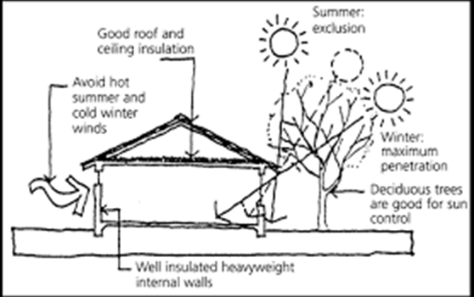

- Calculate zenith angle of the sun at Lucknow (26.750 N) at 9:30 am on February 16, 2012.
Solution:
Total No. of days counted from January 1, 2012, till February 16, 2012, n = 47
From Eq. (2.8), the declination angle is given by
d= 23.45 ⋅ sin [360 ⋅ (284 + n)/365]
= 23.45 ⋅ sin [360 ⋅ (284 + 47)/365]
= −12.95°= −13° (approximately)

